Data :

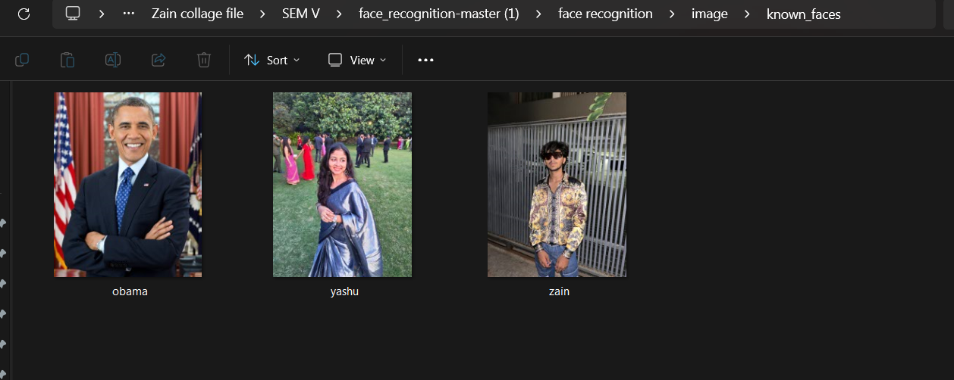

Test case :

1. Single Face:

Input: Image with one face

Expected Output: Detect one face

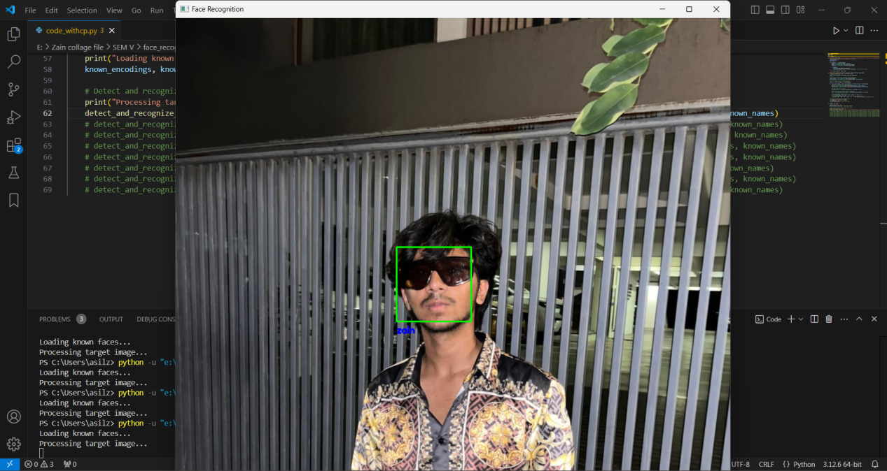

1. Multiple Faces:

Input: Image with multiple faces

Expected Output: Detect all faces

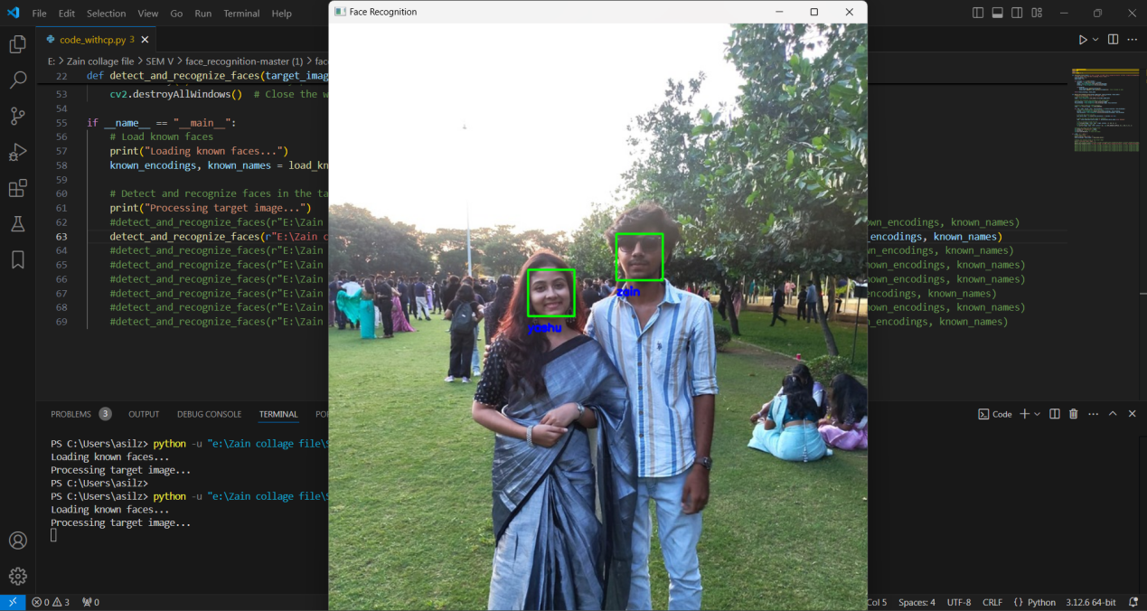

1. No Face:

Input: Image with no faces

Expected Output: No face detected

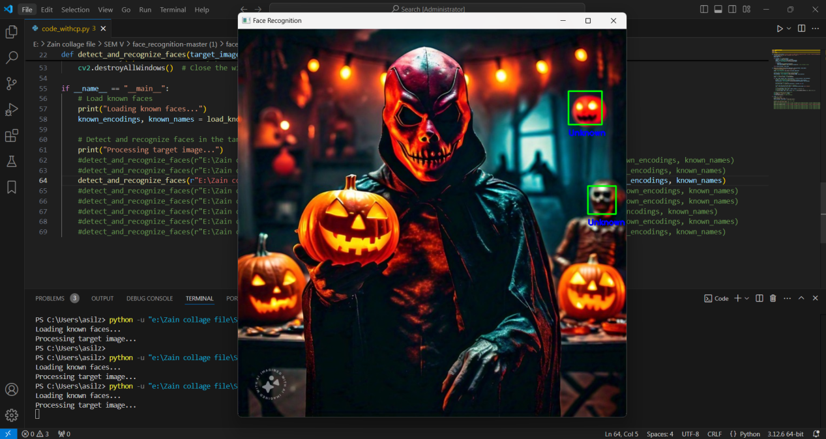

1. Different Orientations:

Input: Images with faces at different angles (e.g., profile, frontal)

Expected Output: Detect faces regardless of orientation

1. Ex 1

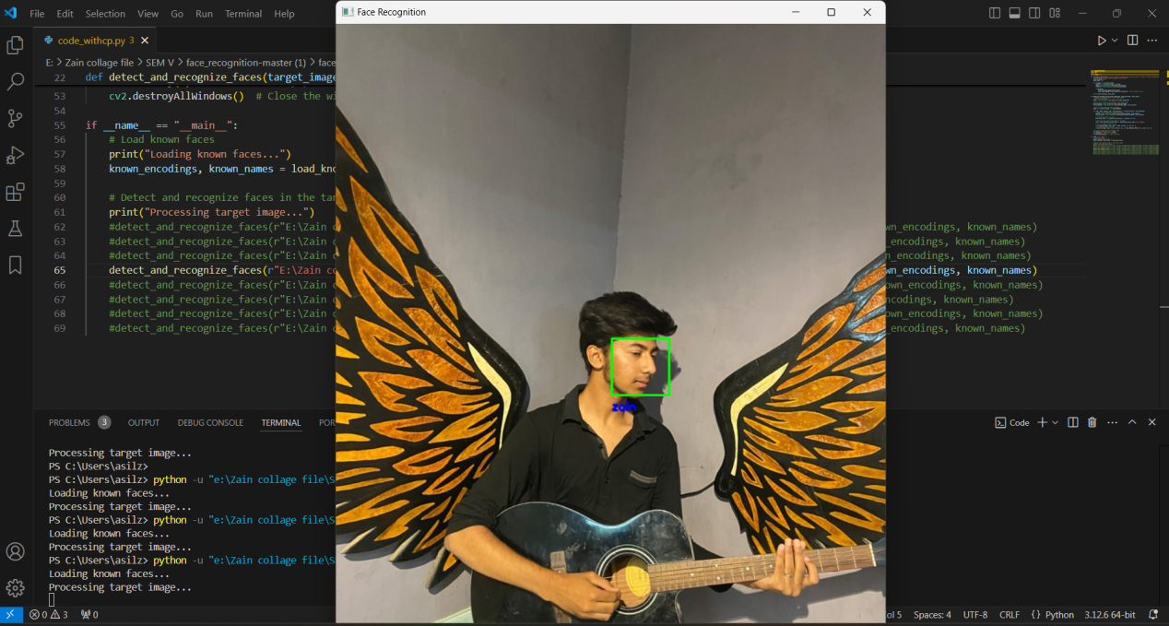

1. Ex 2

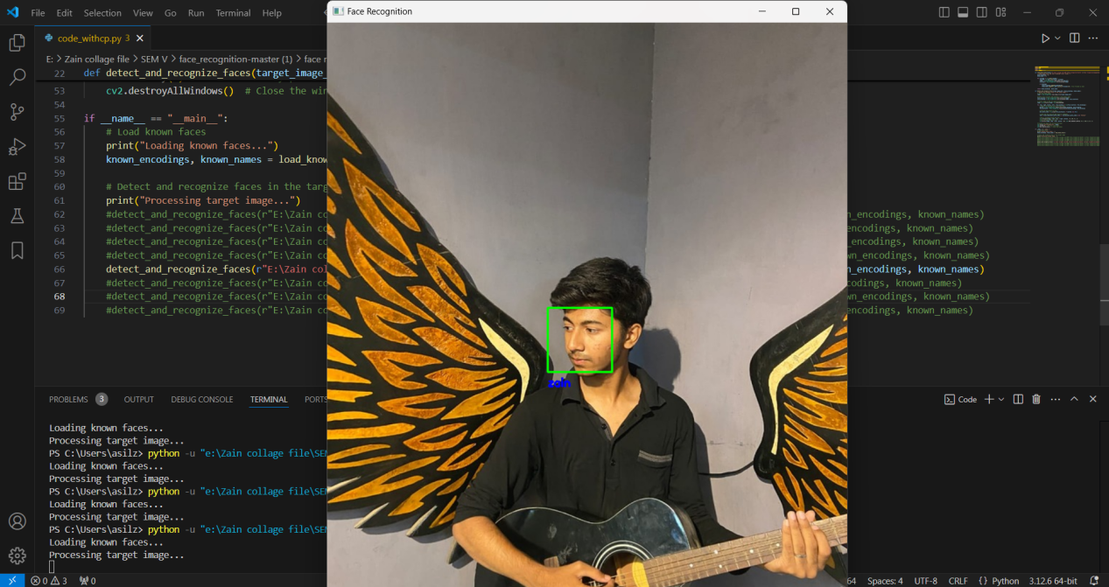

1. Various Lighting Conditions:

Input: Images with different lighting conditions (e.g., bright, dim, backlight)

Expected Output: Detect faces regardless of lighting

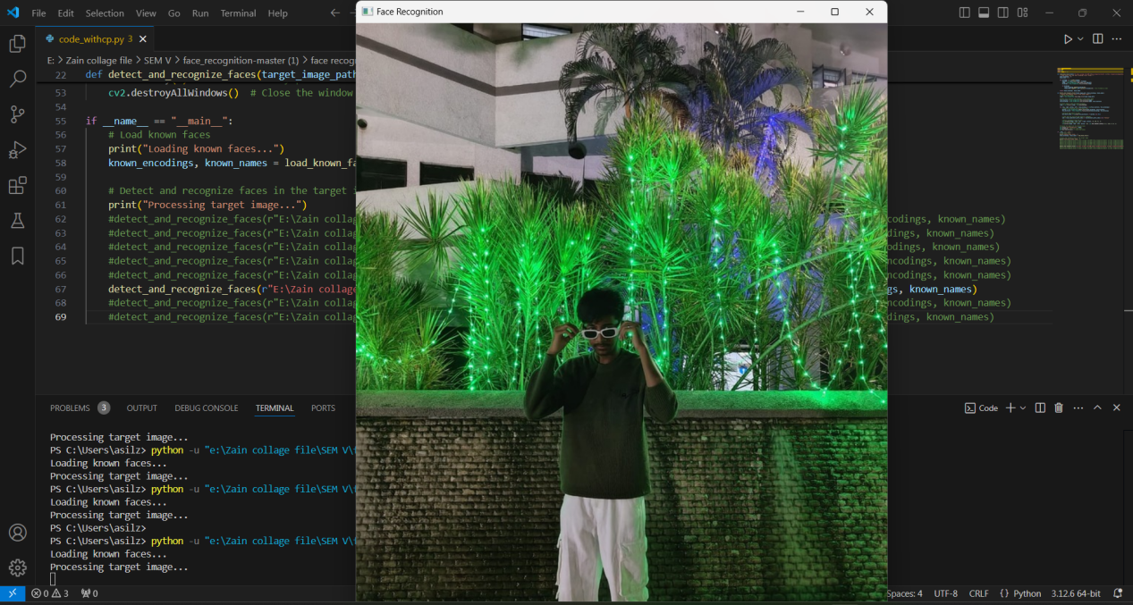

1. Occluded Face:

Input: Image with face partially occluded by objects (e.g., sunglasses, hat)

Expected Output: Detect face with reduced accuracy

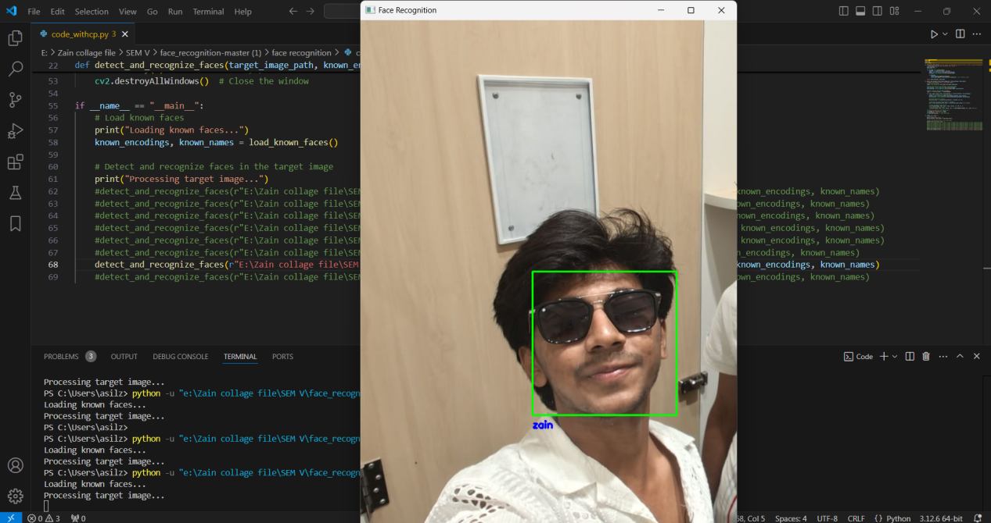

1. Group Photo:

Input: Image with multiple faces in a group

Expected Output: Detect all faces

1. Ex 1

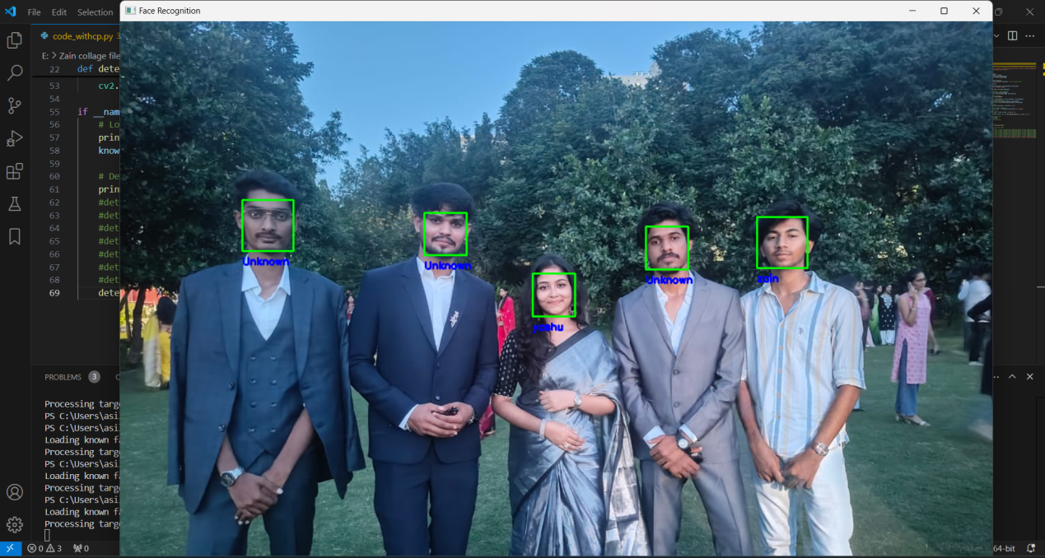

1. Ex 2

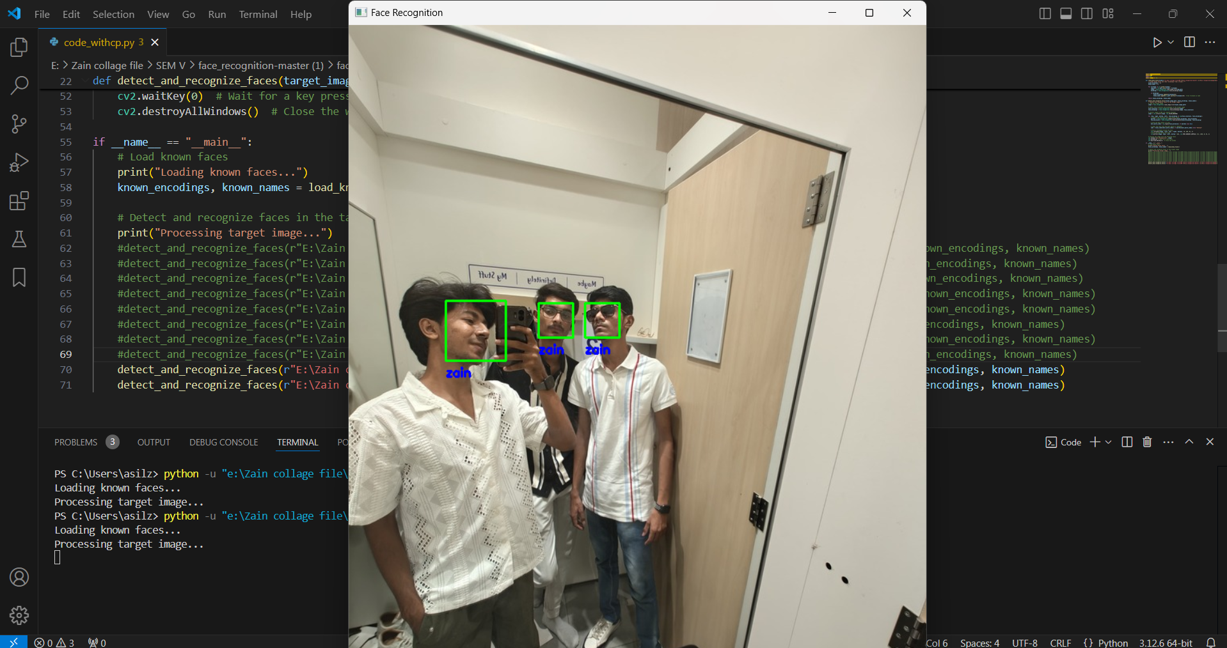

1. Ex 3

